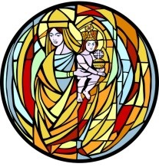
Our Lady of Prompt Succor
Parish School of Religion
For children who do not attend Catholic school

2025 – 2026 K – 10th Grade Calendar
Contact Shanon Alfonso at salfonso@olps-chalmette.org
Daytime phone 504-271-3441 ext 0 - Evening phone (during class only) 504-512-5960

All K-10th Grades Classes are on Monday night from 6:30 pm to 8:00 pm
All students are to be dropped off in the gym by 6:30pm but no earlier than 6:15pm.
All students will be dismissed from the gym carline at 8:00pm
PSR students attend mass together once per month. All students are to be dropped off in the gym and will be walked to church by their teachers. Mass begins promptly at 6:45pm. Parents/families are invited.

August
3 Blessing of the Backpacks Sunday, 10:30am Mass – All invited to bring their backpacks to be blessed.
18 First night of PSR - Mass and Parent meeting – (All meet in the Church)
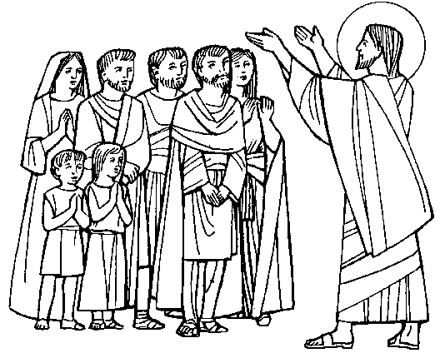
24 Sunday, 10:30am 8th – 12th Grade Family Mass
25 Class

September
1 NO CLASS Labor Day
8 Class - PSR Mass
15 Class
21 Catechetical Sunday 10:30am Mass – All catechists attend
22 Class
28 Sunday, 10:30am 7th Grade Family Mass (Family Day - refreshments and social following)
29 Class
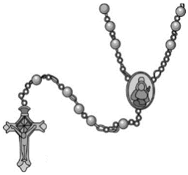

October
6 Class - PSR Mass followed by Living Rosary

13 No Class – Fall Break
19 10:30am 6th Grade Family Mass
20 Class
27 Class


November
3 Class - PSR Mass
10 Class – First Reconciliation Parent Session
16 10:30am Sunday Family Mass - 5th Grade
17 Class
24 NO CLASS - Happy Thanksgiving Holidays
December
1 Class – Reconciliation for grades 3 – 10
6 Santa Breakfast and Santa’s Secret Workshop (Purchase tickets in advance or at the door)
8 Class - PSR Mass in Gym– Christmas carols following
14 10:30am Sunday Family Mass - 4th Grade

15 NO CLASS – Have a Blessed Christmas and Happy New Year
22 NO CLASS – Have a Blessed Christmas and Happy New Year
29 NO CLASS – Have a Blessed Christmas and Happy New Year

January
5 Class - PSR Mass
11 First Reconciliation Family Prep Day 9:00am-11:30am – (Student and parents attend.)
11 10:30am Sunday Family Mass - 3rd Grade
12 Class
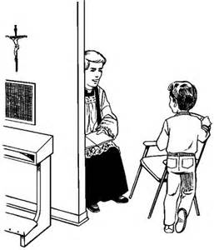
19 NO CLASS – MLK Holiday
21 Wednesday, First Reconciliation - 6:00pm in church
26 Class

February
1 10:30am Sunday Family Mass – 2nd Grade
2 Class - PSR Mass Day
9 Class - Meeting 1st Communion parents in cafeteria 6:30pm
16 No Class – Mardi Gras Break
23 Class


March
2 Class - PSR Mass Day
9 Class
16 Class
22 1st Grade Family Mass 10:30am Sunday
23 Class - Reconciliation in Church – Grades 3rd through 10th
30 LAST PSR CLASS – K-7th grade (All meet in church) Closing Mass

April
6 No Class – Easter Break
12 PreK – K Family Mass
13 LAST PSR CLASS – 8th- 10th grade (All meet in Church)
17-19 Tomato Fest
26 First Communion Family Prep Day 9:00am – 11:30am (Students attend with parent)
27 PSR First Eucharist Rehearsal and Family prayer service (All Students + 1parent) 6:30pm in Church

MAY
3 1st Communion and May Crowning 8:30am Mass or 1:00pm Mass (Spanish)

